Performance Prediction and Optimization of Supercapacitors Through Data-Driven Analysis

A Project Report

submitted by

ASHISH PRATAP SINGH (EC21B1092)

in partial fulfilment of requirements for the award of the degree of

BACHELOR OF TECHNOLOGY



Department of Electronics and Communication Engineering INDIAN INSTITUTE OF INFORMATION TECHNOLOGY, DESIGN AND MANUFACTURING KANCHEEPURAM
May 2025

DECLARATION OF ORIGINALITY

I, Ashish Pratap Singh, with Roll No: EC21B1092 hereby declare that the material presented in the Project Report titled Performance Prediction and Optimization of Supercapacitors Through Data-Driven Analysis represents original work carried out by me in the Department of Electronics and Communication Engineering at the Indian Institute of Information Technology, Design and Manufacturing, Kancheepuram. With my signature, I certify that:
- I have not manipulated any of the data or results.

- I have not committed any plagiarism of intellectual property. I have clearly indi- cated and referenced the contributions of others.

- I have explicitly acknowledged all collaborative research and discussions.

- I have understood that any false claim will result in severe disciplinary action.

- I have understood that the work may be screened for any form of academic mis- conduct.



Ashish Pratap Singh

Place: Chennai Date: 09.05.2025

CERTIFICATE

This is to certify that the report titled Performance Prediction and Optimization of Supercapacitors Through Data-Driven Analysis, submitted by Ashish Pratap Singh (EC21B1092), to the Indian Institute of Information Technology, Design and Manufacturing Kancheepuram, for the award of the degree of BACHELOR OF TECH- NOLOGY is a bona fide record of the work done by him/her under my supervision. The contents of this report, in full or in parts, have not been submitted to any other Institute or University for the award of any degree or diploma.

Dr. S.Kalpana
Project Guide Assistant Professor

Department of Electronics and Communication Engineering IIITDM Kancheepuram, 600 127

Place: Chennai Date: 09.05.2025

ACKNOWLEDGEMENTS

I would like to express my deepest gratitude to my project guide, Dr. S. Kalpana, for her invaluable support, guidance, and motivation throughout the duration of this project. Her expertise and insights have been instrumental in shaping the research and ensuring its successful completion.
I extend my sincere appreciation to IIITDM Kancheepuram for providing access to research materials and computational resources, which greatly contributed to the progress of this study. I am also thankful to my colleagues and peers for their construc- tive discussions, encouragement, and technical assistance.
A special thanks to my family and friends, whose constant support and motivation have kept me focused and determined to achieve my goals. This work would not have been possible without their unwavering belief in me.
Finally, I acknowledge the contributions of researchers and scholars whose work has laid the foundation for this study. Their valuable insights have guided me throughout my research.

ABSTRACT

Supercapacitors have emerged as a leading class of energy storage devices, offering high power density, rapid charge-discharge capabilities, and long cycle life. However, optimizing their performance through conventional experimentation is time-consuming and resource-intensive due to the vast combinatorial space of materials and testing con- ditions. This project explores a machine learning-based approach to enhance superca- pacitor design by addressing two key challenges: (1) predicting areal capacitance based on device configuration and operating parameters, and (2) recommending optimal com- binations of substrate, electrodes, electrolytes, and electrolyte concentration to achieve desired performance metrics such as capacitance, energy density, and power density.
The first part of the study employed regression algorithms including Support Vector Regression (SVR), Decision Tree, XG Boost, Linear Regression and Random Forest Regression to estimate areal capacitance using input features such as specific surface area, pore width, pore volume, pore size, Id/Ig ratio, N% and O%. The second part uti- lized models such as Decision Trees, Random Forests, XG Boost and Gradient Boost- ing to identify ideal material combinations for target performance ranges. Results from the capacitance prediction models showed excellent agreement between predicted and actual values, with R² scores of 0.95 for the best model. Material prediction models achieved accuracy exceeding 99% in predicting suitable material combinations. This dual-approach methodology highlights the feasibility of using machine learning for per- formance optimization and accelerated materials discovery in supercapacitor research. KEYWORDS: Supercapacitor; Carbon based electrode; Machine Learning.

TABLE OF CONTENTS

ACKNOWLEDGEMENTS | i
ABSTRACT | ii
LIST OF TABLES | v
LIST OF FIGURES | vi
ABBREVIATIONS | vii
1 Introduction | 1
1.1 Introduction . . . . . . . . . . . . . . . . . . . . . . . . . . . . . . | 1
1.1.1 Background . . . . . . . . . . . . . . . . . . . . . . . . . . | 1
1.1.2 Motivation and Problem Statement . . . . . . . . . . . . . . | 1
1.1.3 Objectives of the Study . . . . . . . . . . . . . . . . . . . . | 2
1.1.4 Scope of the Report . . . . . . . . . . . . . . . . . . . . . . | 3
1.1.5 Organization of the Report . . . . . . . . . . . . . . . . . . | 3
1.2 Chapter Summary . . . . . . . . . . . . . . . . . . . . . . . . . . . | 4
2 Literature Review | 5
2.1 Supercapacitor Fundamentals . . . . . . . . . . . . . . . . . . . . . | 5
2.1.1 Types of Supercapacitors . . . . . . . . . . . . . . . . . . . | 5
2.1.2 Key Performance Metrics . . . . . . . . . . . . . . . . . . | 6
2.1.3 Applications of Supercapacitors . . . . . . . . . . . . . . . | 7
2.2 Influence of Electrodes and Electrolytes . . . . . . . . . . . . . . . | 7
2.2.1 Electrode Materials . . . . . . . . . . . . . . . . . . . . . . | 8
2.2.2 Electrolyte Selection . . . . . . . . . . . . . . . . . . . . . | 8
2.2.3 Effect of Electrode-Electrolyte Interactions . . . . . . . . . | 8
2.3 Applications of ML in Material Science . . . . . . . . . . . . . . . | 9

  - Chapter Summary . . . . . . . . . . . . . . . . . . . . . . . . . . . 9
- METHODOLOGY 10
  - Data Collection and Preprocessing . . . . . . . . . . . . . . . . . . 10
    - Sources of Data . . . . . . . . . . . . . . . . . . . . . . . . 10
    - Capacitance Prediction Dataset . . . . . . . . . . . . . . . . 10
    - Material Prediction Dataset . . . . . . . . . . . . . . . . . . 11
  - Data Analysis . . . . . . . . . . . . . . . . . . . . . . . . . . . . . 12
    - Capacitance Prediction Data Analysis . . . . . . . . . . . . 12
    - Material Prediction Data Analysis . . . . . . . . . . . . . . 16
  - ML Algorithms . . . . . . . . . . . . . . . . . . . . . . . . . . . . 20
    - Machine Learning Models for Capacitance Prediction . . . 20
    - Machine Learning Models for Material Prediction . . . . . 21
    - Evaluation Metrics . . . . . . . . . . . . . . . . . . . . . . 22
  - Chapter Summary . . . . . . . . . . . . . . . . . . . . . . . . . . . 22
- RESULTS AND DISCUSSION 23
  - Capacitance Prediction . . . . . . . . . . . . . . . . . . . . . . . . 23
    - Performance Comparison . . . . . . . . . . . . . . . . . . . 23
  - Material Prediction . . . . . . . . . . . . . . . . . . . . . . . . . . 26
    - Performance Comparison . . . . . . . . . . . . . . . . . . . 26
  - Chapter Summary . . . . . . . . . . . . . . . . . . . . . . . . . . . 29
- CONCLUSION AND FUTURE SCOPE 30
  - Conclusion . . . . . . . . . . . . . . . . . . . . . . . . . . . . . . 30
  - Future Scope . . . . . . . . . . . . . . . . . . . . . . . . . . . . . 31
  - Chapter Summary . . . . . . . . . . . . . . . . . . . . . . . . . . . 32

LIST OF TABLES

  - Capacitance Prediction Dataset [1]. . . . . . . . . . . . . . . . . . . 11
  - Dataset used for Material Prediction - Part 1 . . . . . . . . . . . . . 12
  - Dataset used for Material Prediction - Part 2 . . . . . . . . . . . . . 13
  - Characteristics of Dataset used for Capacitance Prediction . . . . . 14
  - Characteristics of Dataset used for Material Prediction . . . . . . . 17

  - Performance comparison of different ML models . . . . . . . . . . 24
  - Comparison of different regression models . . . . . . . . . . . . . . 28

LIST OF FIGURES
  - Comparison of Electrochemical Double-Layer Capacitors (EDLCs)(a), Hybrid Supercapacitors (b), and Pseudocapacitors (c) [2]. . . . . . . 6
  - Scatter plots showing the relationship between Capacitance (F/g) and
four input features: PW (V), SSA, PV, and PS. . . . . . . . . . . . . 14
  - Scatter plots illustrating the relationship between Capacitance (F/g) and
two chemical structure features: ID/IG and nitrogen content (N%). 15
  - Scatter plot showing the relationship between Capacitance (F/g) and oxygen content (O%). . . . . . . . . . . . . . . . . . . . . . . . . . 16
  - Distribution of different types of electrode (left) and electrolyte (right) materials. . . . . . . . . . . . . . . . . . . . . . . . . . . . . . . . 18
  - Distribution of different types of substrate materials. . . . . . . . . 18
  - Pearson correlation heatmap showing the relationship among key elec- trochemical features. Strong positive and negative correlations are rep- resented by red and blue colors respectively, with the intensity indicat-
ing the strength of correlation. . . . . . . . . . . . . . . . . . . . . 19
  - Actual vs. Predicted Capacitance for various models: XGBoost, Ran- dom Forest, Decision Tree, Neural Net (MLP), SVR (Tuned), Linear
Regression (Polynomial), and the final Stacked Model. . . . . . . . 25
  - Demonstrating the user interface and interaction flow. . . . . . . . . 27

ABBREVIATIONS

EDLC Electric Double Layer Capacitance
ML Machine Learning
SSA Specific Surface Area
PV Pore Volume
PW Potential Window
PS Pore Size
ID/IG Ratio of D-band to G-band in Raman Spectroscopy (Indicates Structural Defects)
PEEK polyetheretherketone

CHAPTER 1

Introduction

  - Introduction

    - Background

Supercapacitors have emerged as promising energy storage solutions because of their exceptional power density, fast charging and discharging rates, and extended opera- tional lifespan. Unlike traditional batteries, which store energy through chemical reac- tions, supercapacitors rely on electrostatic charge separation, allowing them to deliver quick bursts of energy [3]. This makes them particularly useful in applications where rapid energy transfer is needed, such as electric vehicles, renewable energy storage, and portable electronics. With growing demands, optimizing supercapacitor performance has become a crucial area of research [4].
The performance of supercapacitors is heavily influenced by the choice of elec- trode material, electrolyte composition, and electrolyte concentration. Researchers have explored various materials, including carbon-based structures (graphene, carbon nan- otubes), transition metal oxides, and conductive polymers, to improve capacitance and energy density [3]. Similarly, electrolytes play a key role in determining ionic con- ductivity and electrochemical stability, further impacting the overall efficiency of the device [5].

    - Motivation and Problem Statement

The demand for lightweight, flexible, and high-performance energy storage devices is growing rapidly with the expansion of wearable electronics, portable sensors, and flex- ible IoT systems. Among various energy storage technologies, supercapacitors have emerged as a promising candidate due to their high power density, long cycle life, and

fast charge/discharge characteristics. Despite these advantages, improving energy den- sity and optimizing the performance of supercapacitors under flexible configurations remains a major challenge. Traditional methods of supercapacitor design involve trial- and-error experimentation, which can be costly and time-consuming, especially given the vast space of possible electrode, electrolyte, and substrate combinations. In this context, machine learning (ML) has emerged as a powerful tool for predicting device performance and identifying optimal material combinations without the need for ex- haustive experimentation. By training ML models on existing experimental data, it becomes possible to accelerate the design of next-generation supercapacitors through data-driven insights. This project leverages machine learning techniques to address two key challenges in supercapacitor research: predicting the areal capacitance based on material and experimental parameters, and identifying the most promising combina- tions of electrode, electrolyte, electrolyte concentration and substrate materials to meet specific performance targets.
The development of efficient and flexible supercapacitors is hindered by the com- plexity of selecting suitable materials and operating conditions that yield desirable elec- trochemical performance. The lack of comprehensive databases and the experimental cost of testing every possible material configuration make the optimization process slow and inefficient. This project addresses the following two central problems:
      - Capacitance Prediction: How can we accurately predict the areal capacitance of a supercapacitor device based on its configuration?
      - Material Combination Recommendation: Given a desired performance range (e.g., energy density, power density, areal capacitance), which combination of electrode, electrolyte, electrolyte concentration and substrate materials is most likely to meet the requirement?

Solving these problems using machine learning offers a pathway to accelerate su- percapacitor research and reduce dependence on physical prototyping.

    - Objectives of the Study

The objectives of this project are twofold, focusing on the application of machine learn- ing techniques to enhance the design and performance optimization of supercapacitor devices:

      - Capacitance Prediction: The first objective is to develop robust machine learn- ing regression models capable of accurately predicting the areal capacitance of supercapacitors. By learning from patterns in experimental data, the models aim to facilitate rapid estimation of areal capacitance without the need for extensive physical prototyping or testing.
      - Material Recommendation: The second objective is to construct machine learn- ing models that can intelligently recommend optimal combinations of electrode, electrolyte, electrolyte concentration and substrate materials to achieve specific target ranges for crucial performance metrics. These include energy density, power density, and areal capacitance three vital indicators of supercapacitor effi- ciency and long-term reliability. The regression framework enables guided ma- terial selection based on desired performance outcomes, aiding researchers in narrowing down experimental efforts.

    - Scope of the Report

This report presents a comprehensive methodology for applying machine learning to supercapacitor research. It includes a literature review covering supercapacitor fun- damentals, material selection, and the role of machine learning in material science. The study details the complete process of data collection, preprocessing, and machine learning model development. Several machine learning models have been successfully implemented—both for predicting capacitance based on material and process parame- ters, and for identifying optimal material combinations to achieve target values of areal capacitance, energy density, and power density. The report further analyzes the results obtained from these models and explores future directions for enhancing material dis- covery through machine learning. The findings provide a solid foundation for advancing predictive tools aimed at optimizing supercapacitor performance.

    - Organization of the Report

This report is organized into five chapters, each addressing a key component of the study. The structure is as follows:

Chapter 1: Introduction
This chapter introduces the motivation for the project, outlining the growing importance of supercapacitors in flexible energy storage applications. It defines the problem state-

ment, objectives, and scope of the work, highlighting the role of machine learning in optimizing supercapacitor performance.

Chapter 2: Literature Review
A comprehensive review of the literature is provided, covering the fundamentals of supercapacitors, types of electrode and electrolyte materials, key performance metrics, and recent advances in the application of machine learning in materials science.

Chapter 3: Methodology
This chapter details the data collection and preprocessing techniques used to construct two datasets—one for capacitance prediction and the other for material recommenda- tion. It also explains the machine learning models implemented, feature analysis, and the evaluation metrics employed.

Chapter 4: Results and Discussion
The performance of various machine learning models is analyzed and discussed in this chapter. Results for both capacitance prediction and material recommendation tasks are presented, along with comparative analyses and key observations based on the evalua- tion metrics.

Chapter 5: Conclusion and Future Scope
The final chapter summarizes the outcomes of the study, emphasizes the effectiveness of the selected models, and outlines future directions, including dataset expansion and real-world validation of model predictions.

  - Chapter Summary

This chapter introduces the need for high-performance, flexible energy storage sys- tems and the challenges in optimizing supercapacitor configurations using traditional trial-and-error methods. It highlights the role of machine learning as a predictive and prescriptive tool to enhance design efficiency. The key problems addressed include predicting areal capacitance and recommending optimal material combinations.

CHAPTER 2

Literature Review

  - Supercapacitor Fundamentals

Supercapacitors, also known as electrochemical capacitors, are energy storage devices that bridge the performance gap between conventional capacitors and rechargeable bat- teries. Instead of depending on chemical transformations like batteries, they store en- ergy through the accumulation of electrostatic charge. This mechanism allows for rapid charging and discharging, high power delivery, and long operational life[3].

    - Types of Supercapacitors

Based on how they store charge, supercapacitors are generally divided into three cate- gories. One type, known as Electrochemical Double-Layer Capacitors (EDLCs), stores energy through the physical separation of charges at the boundary between the elec- trode surface and the electrolyte. Materials like activated carbon and graphene are widely utilized due to their extensive surface area and superior electrical conductiv- ity [3]. Pseudocapacitors, in contrast, store energy through faradaic charge transfer involving redox reactions. Transition metal oxides such as MnO₂ and RuO₂, along with conductive polymers, are commonly used as electrode materials due to their excellent electrochemical properties [6]. Lastly, Hybrid Supercapacitors combine the strengths of EDLCs and pseudocapacitors by integrating both electrostatic and faradaic charge storage mechanisms. An example of this is asymmetric supercapacitors, where one electrode functions as an EDLC and the other as a pseudocapacitor [7]. Figure 2.1 illustrates all three types of supercapacitors.

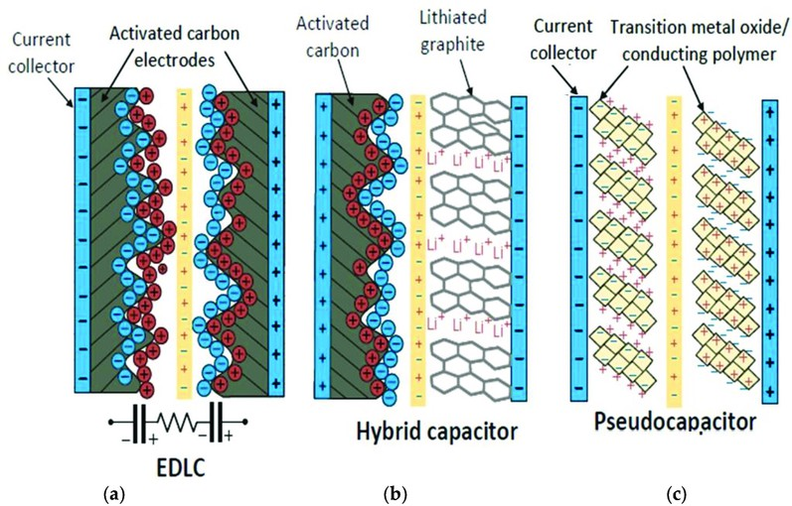
Figure 2.1: Comparison of Electrochemical Double-Layer Capacitors (EDLCs)(a), Hy- brid Supercapacitors (b), and Pseudocapacitors (c) [2].

    - Key Performance Metrics

Several parameters define the efficiency and performance of supercapacitors:

      - Capacitance (C): The ability of a supercapacitor to store charge, measured in farads (F). It depends on the surface area and porosity of electrode materials.
      - Energy Density (E): Indicates the amount of energy stored per unit volume or mass, given by the equation:
1
E = CV ² (2.1)
2
where is the operating voltage.
      - Power Density (P): Determines how quickly the stored energy can be delivered, crucial for applications requiring high bursts of power.
      - Cyclability: Indicates lifespan of a supercapacitor, measured by the number of charge-discharge cycles it can endure before experiencing significant perfor- mance deterioration. [3].

    - Applications of Supercapacitors

Due to their fast charge-discharge capability, supercapacitors are widely used across various applications. In the context of renewable energy systems, supercapacitors con- tribute to grid stability by capturing surplus energy during periods of high solar or wind output and supplying it when generation drops. This boosts overall efficiency and helps lower reliance on fossil fuels. In electric vehicles (EVs), they support rapid acceleration and recover energy during braking, working alongside lithium-ion batteries to manage sudden power surges and enhance battery lifespan[8]. They also play a crucial role in consumer electronics, serving as power backups for memory chips, smartwatches, and portable medical devices, ensuring uninterrupted operation due to their rapid charging ability and sustained power delivery [9]. Additionally, in public transportation systems, supercapacitors are increasingly integrated into buses and trams, enabling quick charg- ing at stops [10] and reducing reliance on fuel-powered transportation. In industrial power management, they are used in cranes, forklifts, and robotic systems to smooth power fluctuations and improve efficiency, ensuring stable and reliable operation in high-power-demand environments [4].

  - Influence of Electrodes and Electrolytes

The performance characteristics of a supercapacitor such as its capacitance, energy den- sity, and overall storage efficiency are heavily influenced by the selection of electrode materials and electrolytes. Research has shown that electrodes made from MXenes of- fer remarkable electrical conductivity along with strong electrochemical stability [11]. Extensive research has focused on materials like graphene oxide and transition metal oxides, including MnO₂ and RuO₂, due to their exceptional charge storage performance [12]. While electrode materials largely determine how electrical charge is accumulated, electrolytes are essential for facilitating ion movement and preserving the system’s sta- bility over time.

    - Electrode Materials

Carbon-Based Electrodes such as activated carbon, graphene, and carbon nanotubes (CNTs) are widely used due to their high surface area, tunable porosity, and excellent electrical conductivity. ese materials are mainly used in electrochemical double-layer capacitors (EDLCs), where energy storage occurs via the separation of charges instead of relying on chemical reactions [3]. Metal Oxides, including MnO, RuO, and NiCoS, provide high capacitance due to their redox reactions, making them ideal for pseudo- capacitive applications. Among these, RuO exhibits one of the highest capacitances but is expensive, leading to research on cost-effective alternatives [12]. A novel family of two-dimensional transition metal carbides and nitrides, referred to as MXenes, ex- hibit metallic conductivity and hydrophilic surfaces, enhancing ion diffusion and charge storage efficiency, showing promising results in hybrid supercapacitors [11].

    - Electrolyte Selection

Electrolytes are essential for defining the voltage range, ion transport efficiency, and overall stability of a supercapacitor. They can be categorized into various types depend- ing on their composition and performance attributes. Aqueous electrolytes are typically composed of acids (HSO), bases (KOH), or neutral salts (NaSO). These electrolytes offer high ionic conductivity but have a limited voltage window of approximately 1V due to water decomposition [13]. Organic electrolytes, based on acetonitrile or propy- lene carbonate solvents, provide a higher voltage window (2.7–3V), enabling higher energy densities. However, they exhibit lower ionic conductivity and pose flammability concerns [14]. Ionic liquids are non-volatile, thermally stable electrolytes that enable ultrahigh voltage operation (>4V). Their high viscosity reduces ionic mobility, but on- going research is improving their performance [15].

    - Effect of Electrode-Electrolyte Interactions

The interplay between electrode materials and electrolytes directly affects the charge storage mechanism and efficiency. Research has indicated that for optimal charge stor-

age, the pore size distribution of carbon electrodes must align with the ionic size of the electrolyte [16]. MXene-based electrodes exhibit excellent compatibility with aqueous and organic electrolytes due to their hydrophilic nature [13]. Pseudocapacitive materi- als like MnO perform best in alkaline electrolytes (e.g., KOH) due to enhanced redox reaction kinetics. Despite their low conductivity, ionic liquids are ideal for high-voltage applications due to their wide electrochemical stability window [15].

  - Applications of ML in Material Science

Machine Learning (ML) is making a big impact in several areas of material science. In the past, scientists had to rely on trial-and-error experiments, which were expen- sive and time-consuming. Now, with ML, computers can quickly analyze data and find patterns that help predict material properties, reducing the need for excessive lab work. It is widely used in predicting material properties, where algorithms can esti- mate characteristics such as conductivity, stability, and capacitance by learning from previous experiments [17]. ML also plays a crucial role in finding new materials by exploring massive databases and suggesting materials with desired properties, acceler- ating the discovery process for researchers [18]. Additionally, ML aids in improving manufacturing processes by adjusting variables like temperature and pressure in real- time to optimize material performance [19]. Another important application is detecting defects, where computer vision powered by ML can identify defects in materials during production, enhancing quality control and reducing waste [20].

Chapter Summary

This chapter provides a foundational understanding of supercapacitor technologies, in- cluding types, working mechanisms, and performance metrics such as capacitance, en- ergy density, and power density. It also surveys various electrode and electrolyte mate- rials and discusses the increasing relevance of machine learning in materials research, particularly in performance prediction and optimization.

CHAPTER 3

METHODOLOGY

Data Collection and Preprocessing

The performance and precision of a machine learning model are heavily influenced by the dataset utilized for both training and testing. For this project, data has been collected from multiple research papers and experimental studies that report the ca- pacitance values of different electrode and electrolyte combinations, along with other material properties.

Sources of Data

The data for this project has been gathered from:

      - Published Research Papers: Journals and conference proceedings that provide detailed experimental results of different supercapacitor materials.
      - Supplementary Materials from Scientific Articles: Some articles include ad- ditional datasets used in their studies, providing valuable numerical data.
      - Gaussian Noise Technique: To address the limitation of a small dataset, the Gaussian noise technique described in [21] was applied to generate an extended dataset.

Capacitance Prediction Dataset

Table 3.1 presents a subset of the collected data used for capacitance prediction. Initially sourced from the research paper by Su et al. (2019) [1], the dataset contained 121 rows, which were later expanded to 1200 rows using the Gaussian noise technique described in the research paper by Bilali et al. (2021)[21].

Table 3.1: Capacitance Prediction Dataset [1].

PW (V) | SSA | PV | PS | ID/IG | N% | O% | Capacitance (F/g)
 | (m²/mg) | (cm³/g) | (nm) |  | (at.%) | (at.%)
0.8 | 0.68 | 0.72 | 4 | 1.62 | 0 | 10.75 | 100
0.8 | 1.38 | 1.2 | 1 | 1.3 | 0 | 9 | 160
1 | 0.38 | 0.51 | 5.4 | 1.15 | 1.53 | 3.1 | 227
1 | 2.01 | 1.6 | 0.55 | 1.12 | 0.1 | 6.27 | 319
1 | 0.34 | 1.6 | 0.62 | 1.38 | 0 | 1.54 | 7.86
1 | 0.3 | 1.5 | 0.62 | 1.25 | 0 | 3.67 | 19.9
1 | 0.34 | 1.59 | 0.62 | 1.22 | 0.54 | 1.8 | 22.2
1 | 0.34 | 1.34 | 0.62 | 1.03 | 1.02 | 2.85 | 29.7
1 | 0.34 | 1.6 | 0.62 | 1.38 | 0 | 1.54 | 2.59
1 | 0.3 | 1.5 | 0.62 | 1.25 | 0 | 3.67 | 34.6

Material Prediction Dataset

The dataset includes various properties that influence capacitance and energy storage ef- ficiency, which are essential for predicting the optimal electrode, electrolyte, electrolyte concentration, and substrate required to achieve a specific target value. The choice of electrode material is critical in influencing capacitance, power density, and energy den- sity. Materials like graphene, RuO₂, MXene, and carbon nanotubes (CNTs) are widely utilized for their exceptional surface area and electrical conductivity [22]. Similarly, the electrolyte type impacts the ionic conductivity and operating voltage range of a super- capacitor, with commonly used electrolytes including aqueous solutions such as H₂SO₄ and KOH, as well as organic solvents and ionic liquids. Polyvinyl alcohol (PVA) serves as a versatile matrix for gel electrolytes due to its excellent film-forming ability and me- chanical stability. When combined with acids like sulfuric acid (H₂SO₄) or phosphoric acid (H₃PO₄), PVA-based GPEs exhibit high ionic conductivity and flexibility. For in- stance, PVA-H₂SO₄ gel electrolytes have demonstrated promising ionic conductivity and specific capacitance performance, making them suitable for flexible energy storage devices [23]. The electrolyte concentration (g/L) directly affects charge transport and ion mobility, influencing both capacitance and overall energy storage efficiency.
Key performance metrics include capacitance (mF/cm²), which quantifies a super- capacitor’s ability to store charge, and energy density (µWh/cm²), representing the total energy stored per unit area, which depends on capacitance and operating voltage. Power density (mW/cm²) is another key factor, as it dictates the rate at which energy can be

delivered. A higher power density allows for faster charge-discharge cycles, making the device well-suited for high-power applications. Furthermore, cyclability (%) indicates how well the supercapacitor retains its performance after multiple charge-discharge cy- cles, with a higher percentage of cyclability reflecting better long-term stability. The number of cycles determines the lifespan of a supercapacitor, referring to the total num- ber of charge-discharge cycles it can undergo before experiencing significant degrada- tion. Tables 3.2 and 3.3 present a subset of the collected data used for the analysis.
Table 3.2: Dataset used for Material Prediction - Part 1

S. No. | Electrode | Substrate | Electrolyte | Electrolyte Conc. (g/l) | Capacitance (mF/cm2) | Current (mA/cm2)
1 | LIG | Kapton PI | PVA-H3PO4 | 85 | 19.47 | 0.04
2 | 2% CNT | Kapton PI | PVA/H2SO4 | 125 | 51.975 | 0.2
3 | 5% CNTs | Kapton PI | PVA/H2SO4 | 125 | 28.375 | 0.2
4 | GO-MnO2 | Kapton PI | PVA-H3PO4 | 5 | 4.02 | 0.5
5 | LIG-MXene | Kapton PI | PVA-H3PO4 | - | 2.19 | 0.1
6 | LIG-C | Parylene-C | PVA/H2SO4 | 85.87 | 1.66 | 0.5
7 | B-doped LIG | Kapton PI | PVA/H2SO4 | 163.49 | 16.5 | 0.05
8 | RuO2/Au | Kapton PI | PVA/H2SO4 | 90.9 | 27 | 2.7
9 | NiCo2S4 | Kapton PI | Co-Ni-Thiourea | 228.36 | 30.4 | 0.75
10 | d-LIG-D | Kapton PI | PVA/H2SO4 | 98.08 | 19.5 | 0.05
11 | LIG | Whatman Paper | PVA/H2SO4 | 87.62 | 4.6 | 0.5
12 | LIG | Lignin | PVA/H2SO4 | 98.08 | 0.88 | 0.02
13 | LIG | Cork | PVA/H2SO4 | 87.62 | 1.35 | 0.05

Data Analysis

Capacitance Prediction Data Analysis

The dataset comprises 1200 records, each characterized by eight distinct features that vary in scale and complexity. This moderate size is ideal for training a wide range of ma- chine learning models, as it balances computational efficiency with sufficient variability to uncover meaningful patterns. Among the features, ’PS’ and ’Capacitance’ demon- strate high variability, with means of 3.15 and 250.6, and standard deviations of 4.81 and

Table 3.3: Dataset used for Material Prediction - Part 2

Scan Rate (mV/s) | Energy Density (µWh/cm2) | Power Density (mW/cm2) | Cyclability (%) | No. of Cycles | Reference
2 | 3.38 | 0.199 | 82 | 1000 | [3]
2 | 6.5 | 0.219 | - | - | [24]
2 | 5.01 | 0.199 | - | - | [24]
10 | 1286.4 | - | 92.59 | 1000 | [12]
10 | - | - | 102.4 | 1000 | [11]
10 | 0.19 | 0.00459 | 96 | 10000 | [25]
10 | - | - | 90 | 12000 | [26]
100 | 3.1 | 2.3 | 80 | 10000 | [27]
5 | 16.9 | 0.368 | 84 | 1000 | [28]
2 | 2.7 | 0.025 | 87.4 | 10000 | [29]
10 | 0.3 | 0.0045 | 96 | 10000 | [30]
10 | 0.152 | 0.025 | 91 | 10000 | [31]
5 | 0.2 | 0.08 | 106 | 10000 | [32]

118.53, respectively. Such elevated levels of dispersion suggest that these features may exhibit nonlinear relationships or interactions that require flexible modeling techniques. Conversely, features like ’PW’ (mean: 0.98, SD: 0.19) and ’ID/IG’ (mean: 1.09, SD: 0.44) show more constrained distributions, indicating potentially more straightforward or stable contributions to the target variable. The dataset also includes compositional attributes such as ’N%’ and ’O%’, which show moderate to high variance (SDs of 3.83 and 5.34, respectively), pointing to differences in material chemistry that could signif- icantly affect electrochemical performance. The presence of noise in the dataset can be inferred from the standard deviation values, with features like ’Capacitance’ show- ing substantial measurement fluctuation, while ’PW’ remains relatively stable. Such variation underscores the importance of using machine learning models capable of han- dling heterogeneous data patterns and mitigating the influence of noise—particularly through techniques such as regularization. Overall, the diversity and spread of the fea- tures reflect a complex underlying structure, which can be effectively explored through robust modeling approaches. The detailed summary of these characteristics is provided in Table 3.4.
Figure 3.1 illustrates scatter plots depicting the relationship between the target vari- able, capacitance (F/g), and four selected input features: PW (V), SSA, PV, and PS. The

Table 3.4: Characteristics of Dataset used for Capacitance Prediction

 | Feature Mean | Std Dev | Min | 25 % | 50 % | 75 % | Max | Noise level (Std Dev)
PW (V) | 0.98 | 0.19 | -0.37 | 0.9 | 1.0 | 1.05 | 1.87 | 0.19
SSA | 1.32 | 0.94 | -0.3 | 0.47 | 1.22 | 1.83 | 4.78 | 0.94
PV | 1.09 | 0.76 | -0.2 | 0.62 | 0.96 | 1.5 | 5.9 | 0.76
PS | 3.15 | 4.81 | 0.03 | 1.27 | 2.17 | 2.99 | 36.25 | 4.81
ID/IG | 1.09 | 0.44 | -0.59 | 0.85 | 1.01 | 1.24 | 4.01 | 0.44
N% | 3.28 | 3.83 | -0.54 | 0.6 | 1.6 | 5.36 | 20.63 | 3.83
O% | 8.69 | 5.34 | -0.25 | 4.6 | 7.48 | 10.99 | 25.3 | 5.34
Capacitance (F/g) | 250.6 | 118.53 | -14.28 | 185.08 | 262.22 | 313.53 | 567.26 | 118.53

distribution of data points in the Capacitance vs. PW (V) plot shows that capacitance values are moderately clustered within a specific voltage range, suggesting a poten- tial but not strongly linear relationship. In the Capacitance vs. SSA plot, the points are widely dispersed, with capacitance values appearing throughout the range of SSA, which indicates that surface area alone may not be a strong independent predictor of capacitance. A similar pattern is seen in the Capacitance vs. PV plot, where although
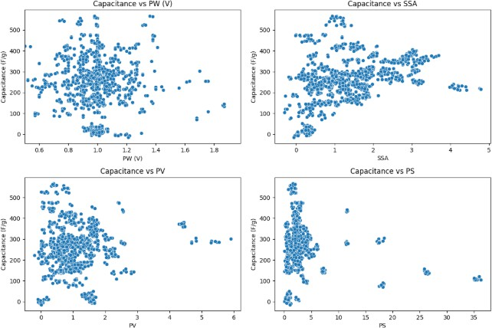

Figure 3.1: Scatter plots showing the relationship between Capacitance (F/g) and four input features: PW (V), SSA, PV, and PS.

a large number of points concentrate at lower pore volume values, high capacitance is achieved across varying levels of PV, implying nonlinear behavior or the influence of other interacting variables. Notably, the Capacitance vs. PS plot exhibits a dense ver- tical cluster of data at lower pore size values, with only a few data points scattered at

higher pore sizes. This could indicate that most materials in the dataset have relatively small pores and that larger pore sizes do not consistently correspond to higher capac- itance. Overall, the visualizations reveal a complex, non-linear relationship between capacitance and these physical characteristics, reinforcing the need for machine learn- ing models capable of capturing such patterns beyond traditional linear assumptions.
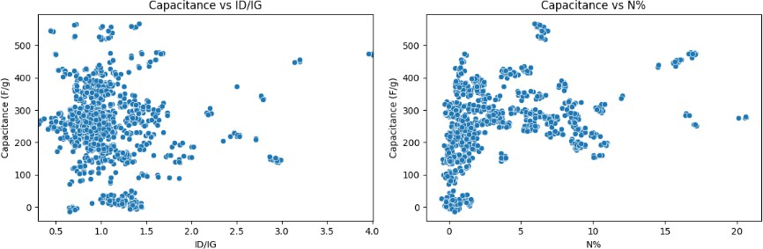
Figure 3.2: Scatter plots illustrating the relationship between Capacitance (F/g) and two chemical structure features: ID/IG and nitrogen content (N%).

Figure 3.2 presents scatter plots that explore the relationship between capacitance and two structural or compositional features: the Raman intensity ratio (ID/IG) and nitrogen content (N%). In the Capacitance vs. ID/IG plot, the data points are largely concentrated between ID/IG values of 0.9 and 1.5, suggesting that most materials fall within this range. While capacitance values are scattered broadly across the vertical axis, some clustering around mid-range capacitance levels can be observed. The lack of a clear trend implies that the ID/IG ratio, which reflects the degree of disorder in carbon materials, may influence capacitance but not in a strictly linear fashion. Similarly, in the Capacitance vs. N% plot, capacitance shows a wide distribution over varying ni- trogen concentrations. Although higher nitrogen content appears in fewer samples, it is associated with both low and high capacitance values, indicating that nitrogen doping might contribute positively to performance, but its effect may depend on interactions with other factors such as pore structure or surface area. The dispersion observed in both plots reinforces the idea that these features impact capacitance in a complex, pos- sibly nonlinear way, and highlights the relevance of machine learning techniques that can model such interactions more effectively than traditional methods.

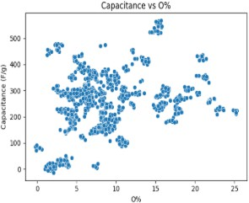
Figure 3.3: Scatter plot showing the relationship between Capacitance (F/g) and oxygen content (O%).

Figure 3.3 presents a scatter plot depicting the relationship between capacitance (F/g) and oxygen content (O%) in the materials. The data points are broadly distributed across the entire range of oxygen concentrations, from near 0% up to approximately 25%. A noticeable concentration of samples appears between 5% and 15% oxygen content, but capacitance values remain widely spread across this interval. While no clear linear trend is evident, the plot suggests that moderate levels of oxygen content are frequently associated with both average and high capacitance values, indicating that oxygen functional groups may play a role in enhancing electrochemical performance. However, the presence of high capacitance values even at lower or higher oxygen per- centages implies that this feature does not solely govern capacitance outcomes. Instead, its influence might be context-dependent, interacting with other structural or composi- tional factors. The overall dispersion of data reinforces the complexity of the relation- ship, underscoring the need for modeling approaches capable of identifying nonlinear patterns and feature interactions within the dataset.

Material Prediction Data Analysis

Table 3.5 provides a summary of the statistical characteristics of the dataset used in this study, including the mean, standard deviation, minimum, 25th percentile, median (50th percentile), 75th percentile, maximum values, and noise level (standard deviation) for each feature. The electrolyte concentration has a mean of 177.536 g/l, with a standard

deviation of 94.296, indicating significant variability across the dataset, ranging from
76.475 g/l to 345.444 g/l. The areal capacitance exhibits considerable variability, with a mean of 24.614 mF/cm² and a standard deviation of 25.255, spanning from 0.005 mF/cm² to 101.930 mF/cm². The current has a mean of 0.526 mA/cm² and a standard deviation of 0.716, with values ranging from a minimum of 0.003 mA/cm² to a max- imum of 2.808 mA/cm². The scan rate shows a wide spread, with a mean of 17.789 mV/s and a standard deviation of 27.951, ranging from 0.100 mV/s to 103.333 mV/s. The energy density has a mean of 4.048 uWh/cm² and a standard deviation of 4.818, with values ranging from 0.003 uWh/cm² to 17.476 uWh/cm². Similarly, power density shows variability, with a mean of 0.616 mW/cm² and a standard deviation of 0.856, ranging from 0.002 mW/cm² to 2.591 mW/cm². The cyclability feature, with a mean of 94.649%, exhibits a high degree of variation, with a standard deviation of 23.592%, and values spanning from 73.047% to 192.398%. Finally, the number of cycles has a mean of 7400.199 cycles, with a standard deviation of 3834.446, reflecting a wide range of cycle numbers from 623.018 to 10443.679 cycles. The noise level, indicated by the standard deviation for each feature, illustrates the inherent variability present in the dataset, which must be taken into account during analysis and model predictions.
Table 3.5: Characteristics of Dataset used for Material Prediction

Feature | Mean | Std Dev | Min | 25 % | 50 % | 75 % | Max | Noise level (Std Dev)
Electrolyte Conc. (g/l) | 177.536 | 94.296 | 76.475 | 89.136 | 183.844 | 276.440 | 345.444 | 94.296
Areal Capacitance (mF/cm²) | 24.614 | 25.255 | 0.005 | 4.350 | 20.344 | 28.657 | 101.930 | 25.255
Current (mA/cm²) | 0.526 | 0.716 | 0.003 | 0.068 | 0.463 | 0.526 | 2.808 | 0.716
Scan Rate (mV/s) | 17.789 | 27.951 | 0.100 | 3.898 | 8.292 | 11.228 | 103.333 | 27.951
Energy Density (µWh/cm²) | 4.048 | 4.818 | 0.003 | 0.468 | 2.768 | 3.595 | 17.476 | 4.818
Power Density (mW/cm²) | 0.616 | 0.856 | 0.002 | 0.074 | 0.272 | 0.616 | 2.591 | 0.856
Cyclability (%) | 94.649 | 23.592 | 73.047 | 81.736 | 92.821 | 97.028 | 192.398 | 23.592
No. of cycles | 7400.199 | 3834.446 | 623.018 | 2816.714 | 9864.716 | 10031.712 | 10443.679 | 3834.446

The left plot of Figure 3.4 reveals that Laser-Induced Graphene (LIG) is the most frequently utilized electrode material, significantly surpassing all others in usage. This trend underscores LIG’s prominence in current research, likely due to its excellent con- ductivity, flexibility, and cost-effective fabrication. LIG/MnO₂ and RuO₂/Au appear

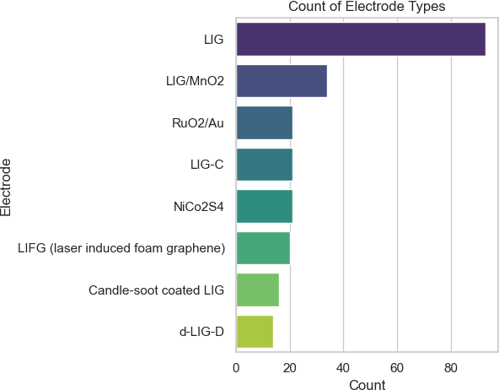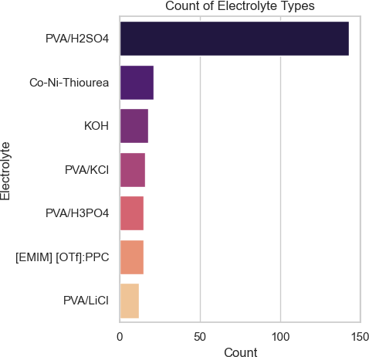
Figure 3.4: Distribution of different types of electrode (left) and electrolyte (right) ma- terials.

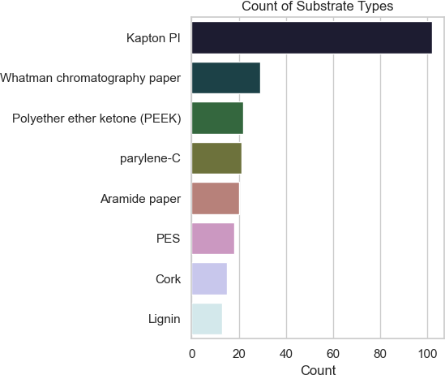

Figure 3.5: Distribution of different types of substrate materials.

next in popularity, reflecting the interest in hybrid structures that enhance electrochem- ical performance through pseudocapacitive contributions. The right plot of Figure 3.4 shows the dominance of PVA/H₂SO₄ as the electrolyte. Its high frequency suggests that this polymer gel electrolyte is favored for its stability, ionic conductivity, and compat- ibility with flexible energy storage devices. In the Figure 3.5, Kapton PI stands out as the most common substrate, likely due to its thermal stability, chemical resistance, and excellent mechanical properties. Other substrates such as Whatman chromatography paper, PEEK, and parylene-C are also represented, pointing to a diverse range of mate- rials being explored for flexible and printable supercapacitor configurations. The wide distribution of substrate types reflects the ongoing experimentation to optimize device flexibility, durability, and compatibility with various fabrication techniques. Together, these plots offer insight into current material preferences in supercapacitor research and provide a foundation for understanding how these selections may influence device performance.
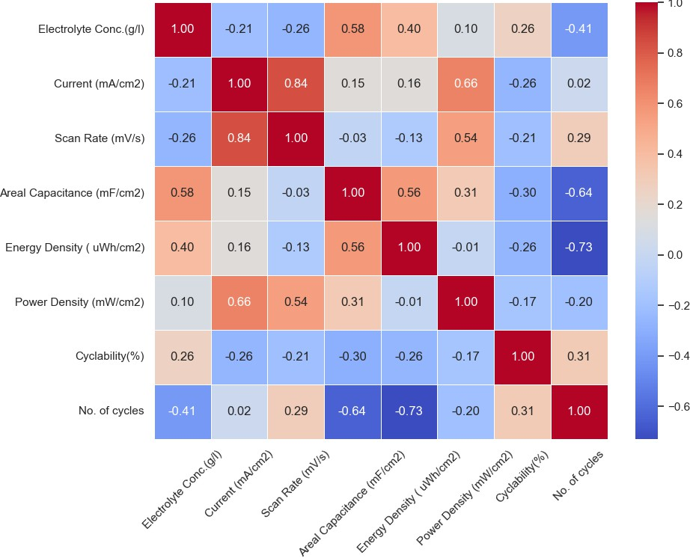

Figure 3.6: Pearson correlation heatmap showing the relationship among key electro- chemical features. Strong positive and negative correlations are represented by red and blue colors respectively, with the intensity indicating the strength of correlation.

The correlation heatmap shown in Figure 3.6 provides key insights into the interde-

pendencies between various parameters affecting supercapacitor performance. Notably, current and scan rate exhibit a strong positive correlation (0.85), highlighting their di- rect relationship during electrochemical measurements. Areal capacitance is positively influenced by both electrolyte concentration (0.60) and energy density (0.61), confirm- ing their significance in energy storage optimization. Conversely, a strong negative correlation between the number of cycles and energy density (-0.75) indicates a trade- off between performance and long-term stability, as high energy configurations may degrade faster. The weak correlation between power and energy density (0.05) fur- ther reinforces the classic energy-power trade-off in electrochemical systems. Overall, the heatmap underscores the critical role of balancing capacitance, power, and stability when designing or predicting optimal configurations.

ML Algorithms

Machine learning (ML) is becoming an essential tool in material science, helping re- searchers make faster and more accurate predictions about material properties. This project aims to develop an ML-based model with two key objectives: first, to predict capacitance based on various electrode properties such as specific surface area, pore size, and pore volume; and second, to determine the optimal combination of substrate materials, electrode materials, electrolyte types, and electrolyte concentrations required to achieve a target areal capacitance,energy density or power density.

Machine Learning Models for Capacitance Prediction

A variety of machine learning algorithms were used to assess the performance of the noise-augmented data. These models included Support Vector Regression (SVR), which is effective for high-dimensional data and capturing non-linear relationships due to its foundation in the Support Vector Machine algorithm. The Decision Tree Regressor was also used, leveraging a tree-based structure that splits data based on feature values to predict the target variable. In addition, the Random Forest algorithm, an ensemble tech- nique that builds multiple decision trees and combines their predictions, was applied to

improve accuracy and minimize overfitting. XGBoost, a powerful gradient boosting algorithm, was utilized for its ability to combine weak learners into a strong predic- tive model. Polynomial Regression, which models the relationship between variables as an nth-degree polynomial, was included to capture non-linear patterns. The Multi- layer Perceptron (MLP), a type of artificial neural network composed of several layers of interconnected neurons, was also employed to model complex relationships in the data. Beyond these individual models, a stacked ensemble approach was adopted by combining the predictions of the top-performing models.

Machine Learning Models for Material Prediction

For model development, a comparative approach was adopted. Four different regres- sion algorithms were selected based on their proven effectiveness in solving structured data problems: Decision Tree Regressor, Random Forest Regressor, Gradient Boost- ing Regressor, and XG Boost Regressor. Each model was integrated into a machine learning pipeline alongside the preprocessing steps. Pipelines ensured that data trans- formations and model fitting occurred seamlessly and reproducibly without information leakage between training and testing phases. An 80-20 training-test split was employed to evaluate the models, where 80% of the data was used for training, and 20% was held out for testing. In practice, the system was designed to first ask the user which per- formance metric they’d like to input—whether it’s areal capacitance, energy density, or power density. Once the user selected a parameter, they were prompted to enter a target value for that metric. Additionally, the user was given the option to choose whether they wanted to use only pure LIG as the electrode material or if they were open to using doped LIG. If they chose to use doped LIG, the model would then recommend the best possible combination of electrode, electrolyte, substrate, and electrolyte concentration to achieve the desired performance. On the other hand, if they preferred only pure LIG, the model would suggest the most suitable combination of electrolyte, substrate, and electrolyte concentration for that choice. This process is depicted in Figure 4.2. Using an 80-20 training-test split, various regression models—Decision Tree, Random Forest, Gradient Boosting, and XG Boost were tested. Based on their performance on the test set, the most accurate model was selected. Great attention was given to prevent over-

fitting, a frequent issue in machine learning where models show strong performance on training data but struggle to generalize to unseen data. Techniques such as regulariza- tion, and early stopping (particularly for XG Boost) were used to mitigate overfitting risks[33].

Evaluation Metrics

To evaluate the models, multiple performance metrics were employed to measure both predictive accuracy and generalization capability. Among these, the R² score was par- ticularly important, as it indicates how much of the variance in the target variable is accounted for by the model. An R² value approaching 1 suggests a strong fit, indicating that the model successfully captures the underlying trends within the data. The Root Mean Square Error (RMSE) was also taken into account, as it quantifies the average deviation between predicted and actual values. A lower RMSE value reflects stronger model performance, indicating that the predicted outputs closely align with the actual values on average. This makes it a sensitive metric for evaluating prediction accuracy, especially when large errors are critical to avoid. Another key evaluation metric is the Mean Absolute Error (MAE), which computes the average of the absolute differences between predicted and actual values. Unlike RMSE, MAE treats all errors equally with- out squaring them, making it less affected by outliers. As with RMSE, a lower MAE indicates that the model’s predictions are generally closer to the true values.

Chapter Summary

The methodology outlines the process of dataset creation, including data collection from literature and augmentation using Gaussian noise. The section also covers the data analysis conducted for both the capacitance prediction and material prediction datasets. It describes the features used for prediction, the regression models employed (SVR, Random Forest, XGBoost, etc.), and evaluation metrics like R², MAE, and RMSE.

CHAPTER 4

RESULTS AND DISCUSSION

Capacitance Prediction

Performance Comparison

Table 4.1 provides a comparative evaluation of several regression models used for predicting a target variable, analyzed through key performance metrics: Root Mean Squared Error (RMSE), Mean Absolute Error (MAE), R² Score, and Accuracy percent- age. Among all the models tested, the Stacked Model demonstrated superior perfor- mance, achieving the lowest RMSE (25.53) and MAE (16.86), alongside the highest R² Score (0.95) and Accuracy (95.36%). These values indicate that the Stacked Model offers both high predictive precision and strong correlation with actual values. In this analysis, the Stacked Model refers to a combined approach that leverages the predic- tive strengths of both Random Forest and XGBoost models. Rather than using these models independently, their predictions are blended typically by averaging to produce a final output. This ensemble approach is designed to exploit the complementary ca- pabilities of both methods. The Random Forest and XGBoost models also performed well, with slightly higher error values but comparable R² scores. Their consistent results confirm the effectiveness of ensemble-based techniques in capturing complex relation- ships in data. In contrast, simpler models like the Decision Tree, Polynomial Linear Regression, Support Vector Regression (SVR), and Neural Networks (MLP) showed significantly higher error values and lower R² scores. For instance, the Decision Tree had an RMSE of 53.68 and an R² of 0.79, indicating poorer predictive performance. The SVR and Neural Net models, in particular, yielded the lowest accuracy, suggesting that either the models were not optimally tuned or the data’s structure did not favor their algorithms.

Table 4.1: Performance comparison of different ML models

Model | RMSE | MAE | R2 Score | Accuracy (%)
Stacked Model | 25.53 | 16.86 | 0.95 | 95.36
Random Forest | 26.96 | 17.35 | 0.95 | 94.82
XGBoost | 29.58 | 17.98 | 0.94 | 93.77
Decision Tree | 53.68 | 39.18 | 0.79 | 79.47
Linear Regression (Poly) | 67.81 | 51.32 | 0.67 | 67.25
SVR (Tuned) | 73.91 | 50.72 | 0.61 | 61.09
Neural Net (MLP) | 73.96 | 56.60 | 0.61 | 61.04

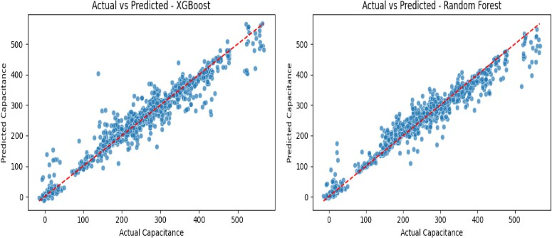

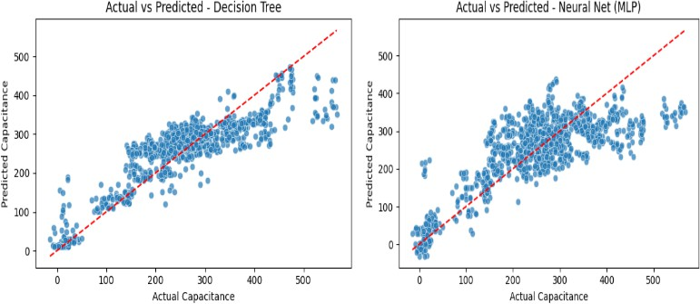

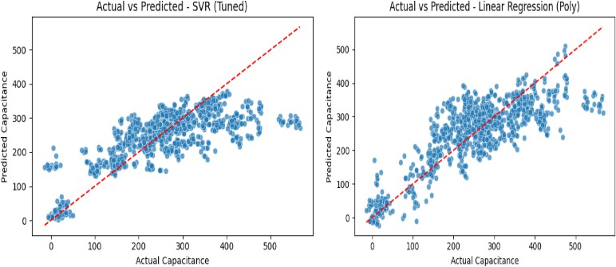

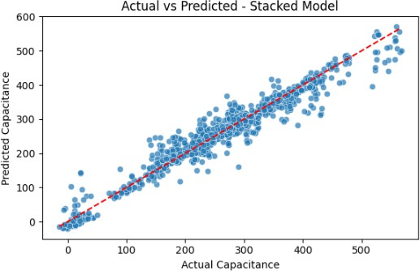
Figure 4.1: Actual vs. Predicted Capacitance for various models: XGBoost, Random Forest, Decision Tree, Neural Net (MLP), SVR (Tuned), Linear Regression (Polynomial), and the final Stacked Model.

The series of scatter plots shown in Figure 4.1 the actual versus predicted capaci- tance values from seven different regression models applied to the same dataset. These include XGBoost, Random Forest, Decision Tree, Neural Net (MLP), Support Vector Regression (SVR Tuned), Polynomial Linear Regression, and a Stacked Model that combines several base models. Each plot uses a red dashed line to represent the ideal scenario where predicted values match actual values perfectly. Among the individual models, XGBoost and Random Forest exhibit strong predictive performance with points closely following the diagonal, indicating low error and good generalization. The SVR and Neural Net models also show decent accuracy, although with slightly more spread. In contrast, the Decision Tree and Polynomial Linear Regression models demonstrate higher variance and poorer alignment, suggesting overfitting and limitations in captur- ing complex patterns. The Stacked Model, which integrates the outputs of multiple base learners, clearly outperforms all individual models. It displays the tightest cluster- ing of points around the ideal line, demonstrating that ensembling improves accuracy and robustness by leveraging the strengths of multiple models while mitigating their individual weaknesses.

Material Prediction

Performance Comparison

This section presents the outcomes of the machine learning modeling phase, in which four regression algorithms—Decision Tree Regressor, Random Forest Regressor, Gra- dient Boosting Regressor, and XGBoost Regressor—were applied to a dataset com- prising 240 supercapacitor configurations. Each model was trained and evaluated us- ing a standard 80-20 train-test split, allowing for a clear assessment of generalization performance on unseen data. To evaluate model performance, three widely accepted regression metrics were used: Mean Absolute Error (MAE), the Pearson correlation coefficient (R), and the Coefficient of Determination (R² score). The Mean Absolute Error (MAE) provides a straightforward measure of the average prediction error, of- fering an easily interpretable assessment of how closely the model’s outputs match the actual values. The correlation coefficient (R) indicates the degree and direction of the

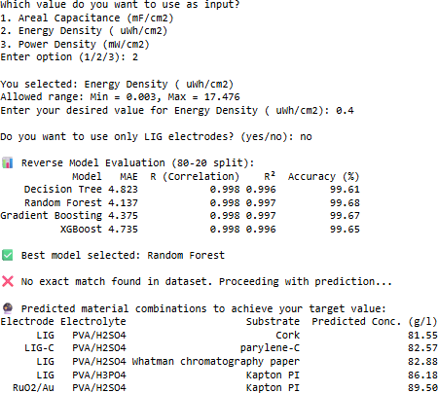

Figure 4.2: Demonstrating the user interface and interaction flow.

linear relationship between predicted and true values, with values near 1 signifying a strong positive correlation. Meanwhile, the R² score represents the fraction of variance in the target variable accounted for by the model, where a value approaching 1 suggests a high-quality fit. These evaluation metrics together provide a comprehensive under- standing of each model’s predictive ability, highlighting their strengths in minimizing error, maintaining consistency, and effectively capturing underlying data trends. This approach supports the identification of models that can reliably predict optimal mate- rial configurations for supercapacitor design, based on the specified target performance criteria.
Figure 4.2 illustrates the execution of the modeling code for an energy density tar- get of 0.4 µWh/cm². To determine the optimal material combination for achieving a specified energy density, a reverse modeling approach was applied using four regres- sion algorithms: Decision Tree, Random Forest, Gradient Boosting, and XGBoost. The models were trained to predict the required optimal material combination based on de- sired performance output. The evaluation of each model was carried out using an 80–20 train-test split to ensure reliability and generalizability. Among the tested algorithms,

the Decision Tree Regressor yielded the most favorable performance in terms of pre- dictive accuracy and correlation with actual values. After selecting this model as the most suitable, it was employed to predict the necessary electrolyte concentrations for achieving an energy density of 0.4 µWh/cm². Although this target value did not match any exact entry in the dataset, the trained model was able to generate plausible mate- rial combinations that closely align with the desired performance. The model’s pre- dictions identified several promising combinations. One such configuration included a LIG electrode with a PVA/H₂SO₄ electrolyte and cork substrate, requiring an estimated concentration of 81.55 g/L. Similarly, LIG paired with PVA/H₂SO₄ and Whatman chro- matography paper substrate was predicted to require approximately 82.88 g/L. Notably, both traditional and hybrid LIG-based electrodes with various substrates such as Kap- ton PI and Whatman chromatography paper demonstrated potential to meet the target energy density within similar concentration ranges. These results highlight the useful- ness of the reverse modeling framework for supercapacitor optimization. By inputting a desired energy density, the model efficiently narrows down compatible material sets and corresponding electrolyte concentrations. This approach not only accelerates ma- terial screening but also supports practical decision-making in experimental design by guiding the synthesis toward data-driven targets. The performance comparison is sum- marized in Table 4.2.
Table 4.2: Comparison of different regression models

Model | MAE | R Value | R2 Value | Accuracy (%)
Decision Tree | 4.823 | 0.998 | 0.996 | 99.61
Random Forest | 4.137 | 0.998 | 0.997 | 99.68
Gradient Boosting | 4.375 | 0.998 | 0.997 | 99.67
XGBoost | 4.735 | 0.998 | 0.996 | 99.65

Among the four models tested, the Random Forest Regressor demonstrated the best performance, achieving a significantly lower Mean Absolute Error (MAE) and a high R² score of 0.997. The R² value indicates that 99% of the variability in the target vari- able (e.g., areal capacitance, energy density, or power density) is explained by the input features. This level of performance suggests strong predictive capability and minimal error in the model’s predictions. In comparison, the Decision Tree, Gradient Boosting, and XGBoost models, while still effective with R² scores of 0.996, 0.997, and 0.996

respectively, exhibited higher errors, suggesting slightly less accurate predictions. The Random Forest’s success can be attributed to its ability to model complex, nonlinear relationships while minimizing error. Although it may not offer the same level of flex- ibility as more advanced models, its high R² and accuracy percentage of 99.68% make it particularly suitable for the task at hand, where straightforward and efficient predic- tions are key. The Gradient Boosting, Decision Tree, and XGBoost models all showed reasonable accuracy but were not able to outperform the Random Forest in terms of MAE or R² which is also shown in Figure 5. Notably, XGBoost, despite being a pop- ular choice for many machine learning tasks, performed the worst in this scenario with an R² value of 0.996 and accuracy of 99.65%. This outcome may be influenced by var- ious factors such as overfitting, data sparsity, or model configuration issues. Overall, the Random Forest stands out as the optimal model for predictive tasks in this context, as well as for other input variables such as areal capacitance and power density. Its combination of high accuracy and reliable predictions makes it a strong candidate for recommending supercapacitor configurations based on user-defined performance tar- gets.

Chapter Summary

This chapter presents and compares the performance of different ML models. For ca- pacitance prediction, the Stacked Model outperformed others with an R² of 0.95. For material recommendation, the Random Forest Regressor achieved the highest accuracy (99.68%) and lowest error. Detailed performance metrics and visualization plots vali- date the model predictions and highlight their applicability.

CHAPTER 5

CONCLUSION AND FUTURE SCOPE

Conclusion

In this study, we evaluated the performance of various machine learning models for pre- dicting capacitance based on multiple input features. We used a range of performance metrics to assess the models, including R² Score, Root Mean Square Error (RMSE), and Mean Absolute Error (MAE), with accuracy derived from the R² Score. As ex- pected, the models showed a marked improvement in performance as the dataset size increased, particularly in the case of more complex models such as Random Forest Regressor and Gradient Boosting Regressor. The Random Forest Regressor was the standout performer across all dataset sizes, achieving the highest R² Score (up to 0.95), which corresponds to 95% accuracy, and the lowest RMSE and MAE values. This demonstrates that Random Forest, with its ability to model complex non-linear rela- tionships in the data, was the most accurate for predicting capacitance. The Decision Tree Regressor and Gradient Boosting Regressor also performed well, especially as the dataset size increased. They showed improvements in R² Scores, reaching 92% and 93% accuracy respectively, but they still lagged behind the Random Forest Regressor. The Linear Regression model, while simpler and easier to interpret, performed reason- ably well with the larger datasets, achieving an accuracy of 88% with the 1200 dataset. However, it was less effective at handling the more complex, non-linear relationships between the input features and capacitance, which is why it was outperformed by the tree-based models.
For optimal material combination prediction, we conducted a comprehensive eval- uation of several machine learning models to predict target performance based on key experimental parameters. The results consistently demonstrated the superior capability of tree-based ensemble models, particularly the Random Forest Regressor, in captur- ing the complex relationships present within the data. The Random Forest Regres-

sor emerged as the best-performing model, achieving the lowest MAE (4.137) and the highest R² Score (0.997), which translates to an accuracy of 99.68%. This high level of precision can be attributed to its ensemble approach, which combines the predic- tions of multiple decision trees, enabling it to effectively model non-linear interactions between features. Other ensemble models like Gradient Boosting and XGBoost also performed well, with R² values of 0.997 and 0.996 respectively, and accuracy exceed- ing 99.6%, but they exhibited slightly higher error margins than Random Forest. The Decision Tree Regressor, while performing reasonably with a R² of 0.996 and accu- racy of 99.61%, showed a slightly higher MAE, indicating less stability compared to its ensemble counterparts. Nevertheless, it still proved capable of modeling the data with high reliability. Overall, the results affirm that Random Forest is the most effective and robust model for this prediction task. Its balance of low error and high accuracy makes it especially well-suited for complex regression problems involving multiple interdepen- dent features. While other models demonstrated strong performance, none consistently matched the predictive power and stability of the Random Forest Regressor in this con- text.

Future Scope

Looking ahead, one of the key directions for future work is to significantly expand the dataset by incorporating a broader range of experimental data from diverse sources. The current dataset, though sufficient for initial model development, may not fully capture the wide variability seen in real-world supercapacitor systems. By including more vari- ations in material types, fabrication methods, and environmental conditions, the model can be trained to handle a more comprehensive set of scenarios. This would increase its robustness and make it more applicable across a wider range of supercapacitor re- search and development tasks. Another valuable extension of this work would involve exploring transfer learning or domain adaptation techniques, where the current model is fine-tuned for related tasks using limited new data. This can be particularly useful when applying the model to new electrode materials or configurations that were not included in the original dataset. Ultimately, future efforts will focus on deploying the model in practical, experimental settings to assess its real-world applicability. By validating the

model’s predictions through actual laboratory tests and performance measurements, its accuracy, reliability, and usefulness can be thoroughly evaluated. These steps will help ensure that the model not only performs well in theory but also serves as a valuable tool for accelerating material discovery and process optimization in the field of energy storage.

Chapter Summary

The final chapter summarizes the effectiveness of the ML-based framework for super- capacitor optimization. It confirms the suitability of Random Forest for both prediction and recommendation tasks. Future directions include expanding the dataset, integrating transfer learning, and validating predictions through experimental work.

REFERENCES
- H. Su, S. Lin, S. Deng, C. Lian, Y. Shang, and H. Liu, “Predicting the capacitance of carbon-based electric double layer capacitors by machine learning,” Nanoscale Advances, vol. 1, no. 6, pp. 2162–2166, 2019.
- K. Subasinghage, K. Gunawardane, N. Padmawansa, N. Kularatna, and M. Mora- dian, “Modern supercapacitors technologies and their applicability in mature elec- trical engineering applications,” Energies, vol. 15, no. 20, p. 7752, 2022.
- M. C. A. de Oliveira, A. L. Freire, I. C. Candido, Y. Messaddeq, J. Lapointe,
J. Fréchette, R. Vallée, and H. P. de Oliveira, “Flexible micro supercapacitor and triboelectric nanogenerator based on laser-induced graphene for self-powered ap- plications,” Next Energy, vol. 4, p. 100141, 2024.
- K. O. Oyedotun and B. B. Mamba, “New trends in supercapacitors applications,”
Inorganic Chemistry Communications, p. 113154, 2024.
- S. Ahmed, M. Rafat, and S. Hashmi, “Effect of electrolyte concentration on su- percapacitor performance of graphene-nio composite,” Int. J. Adv. Res. Sci. Eng., vol. 6, pp. 609–614, 2017.
- A. González, E. Goikolea, J. A. Barrena, and R. Mysyk, “Review on supercapac- itors: Technologies and materials,” Renewable and sustainable energy reviews, vol. 58, pp. 1189–1206, 2016.
- D. P. Chatterjee and A. K. Nandi, “A review on the recent advances in hybrid supercapacitors,” Journal of Materials Chemistry A, vol. 9, no. 29, pp. 15 880–
15 918, 2021.
- M. Horn, J. MacLeod, M. Liu, J. Webb, and N. Motta, “Supercapacitors: A new source of power for electric cars?” Economic Analysis and Policy, vol. 61, pp. 93–103, 2019.
- A. Berrueta, A. Ursua, I. San Martin, A. Eftekhari, and P. Sanchis, “Supercapac- itors: electrical characteristics, modeling, applications, and future trends,” Ieee Access, vol. 7, pp. 50 869–50 896, 2019.
- M. Khodaparastan and A. Mohamed, “Supercapacitors for electric rail transit sys- tems,” in 2017 IEEE 6th International Conference on Renewable Energy Research and Applications (ICRERA). IEEE, 2017, pp. 896–901.
- X.-Y. Fu, R.-Y. Shu, C.-J. Ma, Y.-Y. Zhang, H.-B. Jiang, and M.-N. Yao, “Self-
assembled mxene-graphene oxide composite enhanced laser-induced graphene based electrodes towards conformal supercapacitor applications,” Applied Surface Science, vol. 631, p. 157549, 2023.

- X.-Y. Fu, R.-Y. Shu, C.-J. Ma, H.-B. Jiang, and M.-N. Yao, “Graphene oxide assisted-mno2 nanoparticles enhanced laser-induced graphene based electrodes for supercapacitor application,” Electrochimica Acta, vol. 481, p. 143987, 2024.
- M. Z. Iqbal, S. Zakar, and S. S. Haider, “Role of aqueous electrolytes on the per- formance of electrochemical energy storage device,” Journal of Electroanalytical Chemistry, vol. 858, p. 113793, 2020.
- A. Acharjee and B. Saha, “Organic electrolytes in electrochemical supercapaci- tors: Applications and developments,” Journal of Molecular Liquids, p. 124487, 2024.
- P. Mohapatra and A. K. Barick, “Ionic liquids based polymer electrolytes for su- percapacitor applications,” Journal of Power Sources, vol. 626, p. 235749, 2025.
- X. Cai, Y. Xiao, and W. Sun, “Pore-size effect of activated carbons on the electro- chemical performances of symmetric supercapacitors under compression,” Jour- nal of Energy Storage, vol. 55, p. 105438, 2022.
- J. Schmidt, M. R. Marques, S. Botti, and M. A. Marques, “Recent advances and applications of machine learning in solid-state materials science,” npj computa- tional materials, vol. 5, no. 1, p. 83, 2019.
- Y. Liu, T. Zhao, W. Ju, and S. Shi, “Materials discovery and design using machine learning,” Journal of Materiomics, vol. 3, no. 3, pp. 159–177, 2017.
- C. Wang, X. P. Tan, S. B. Tor, and C. Lim, “Machine learning in additive manu- facturing: State-of-the-art and perspectives,” Additive Manufacturing, vol. 36, p. 101538, 2020.
- E. Westphal and H. Seitz, “A machine learning method for defect detection and visualization in selective laser sintering based on convolutional neural networks,” Additive Manufacturing, vol. 41, p. 101965, 2021.
- A. E. Bilali, A. Taleb, M. A. Bahlaoui, and Y. Brouziyne, “An integrated approach based on gaussian noises-based data augmentation method and adaboost model to predict faecal coliforms in rivers with small dataset,” Journal of Hydrology, vol. 599, p. 126510, 2021.
- K. Wang, L. Li, Y. Li, L. Tao, L. Wang, S. Yuan, H. Fu, C. Geng, and X. Xu, “Preparation of graphene carbon nanotube supercapacitor electrode materials for new energy vehicles,” Materials Technology, vol. 39, no. 1, p. 2372945, 2024.
- G. D’Altri, L. Yeasmin, V. Di Matteo, S. Scurti, A. Giovagnoli, M. F. Di Filippo,
I. Gualandi, M. C. Cassani, D. Caretti, S. Panzavolta et al., “Preparation and char- acterization of self-healing pva–h2so4 hydrogel for flexible energy storage,” ACS omega, vol. 9, no. 6, pp. 6391–6402, 2024.
- H. Tariq, S. U. Awan, D. Hussain, S. Rizwan, S. A. Shah, S. Zainab, and M. B. Riaz, “Enhancing supercapacitor performance through design optimization of laser-induced graphene and mwcnt coatings for flexible and portable energy stor- age,” Scientific Reports, vol. 13, no. 1, p. 21116, 2023.

- R. Correia, J. Deuermeier, M. R. Correia, J. Vaz Pinto, J. Coelho, E. Fortunato, and R. Martins, “Biocompatible parylene-c laser-induced graphene electrodes for microsupercapacitor applications,” ACS applied materials & interfaces, vol. 14, no. 41, pp. 46 427–46 438, 2022.
- Z. Peng, R. Ye, J. A. Mann, D. Zakhidov, Y. Li, P. R. Smalley, J. Lin, and J. M. Tour, “Flexible boron-doped laser-induced graphene microsupercapacitors,” ACS nano, vol. 9, no. 6, pp. 5868–5875, 2015.
- K. Brousse, S. Pinaud, S. Nguyen, P.-F. Fazzini, R. Makarem, C. Josse, Y. Thi- mont, B. Chaudret, P.-L. Taberna, M. Respaud et al., “Facile and scalable prepara- tion of ruthenium oxide-based flexible micro-supercapacitors,” Advanced Energy Materials, vol. 10, no. 6, p. 1903136, 2020.
- G. K. Maron, M. G. Masteghin, V. Gehrke, L. S. Rodrigues, J. H. Alano, J. H. Rossato, V. R. Mastelaro, J. Dupont, M. T. Escote, S. R. P. Silva et al., “Enhanced pseudocapacitive behaviour in laser-written graphene micro-supercapacitors dec- orated with nickel cobalt sulphide nanoparticles,” Materials research bulletin, vol. 168, p. 112490, 2023.
- C. Ryu, H. M. Do, and J. B. In, “Enhanced performance of densified laser-induced graphene supercapacitor electrodes in dimpled polyimide,” Applied Surface Sci- ence, vol. 643, p. 158696, 2024.
- J. Coelho, R. F. Correia, S. Silvestre, T. Pinheiro, A. C. Marques, M. R. P. Correia,
J. V. Pinto, E. Fortunato, and R. Martins, “based laser-induced graphene for sus- tainable and flexible microsupercapacitor applications,” Microchimica Acta, vol. 190, no. 1, p. 40, 2023.
- F. Mahmood, H. Zhang, J. Lin, and C. Wan, “Laser-induced graphene derived from kraft lignin for flexible supercapacitors,” ACS omega, vol. 5, no. 24, pp. 14 611–14 618, 2020.
- S. Silvestre, T. Pinheiro, A. Marques, J. Deuermeier, J. Coelho, R. Martins,
L. Pereira, and E. Fortunato, “Cork derived laser-induced graphene for sustain- able green electronics. flex print electron 7: 035021,” 2022.
- Y. Tian and Y. Zhang, “A comprehensive survey on regularization strategies in machine learning,” Information Fusion, vol. 80, pp. 146–166, 2022.

Final Project report

ORIGINALITY REPORT
13

%
SIMILARITY INDEX
7%
INTERNET SOURCES
8%
PUBLICATIONS
6%
STUDENT PAPERS

PRIMARY SOURCES

1 Submitted to Indian Institute of Information Technology, Design and Manufacturing -
Kancheepuram
Student Paper

2 R. N. V. Jagan Mohan, B. H. V. S. Rama Krishnam Raju, V. Chandra Sekhar, T. V. K. P.
Prasad. "Algorithms in Advanced Artificial Intelligence - Proceedings of International Conference on Algorithms in Advanced
Artificial Intelligence (ICAAAI-2024)", CRC
Press, 2025
Publication

3 Submitted to UNESCO-IHE Institute for Water Education
Student Paper

4 Azega, R. K.. "Engineering Wood-Derived Supercapacitors for Sustainable Energy
Storage Solutions.", Chalmers Tekniska Hogskola (Sweden)
Publication

5 "Handbook of Nanocomposite Supercapacitor Materials II", Springer Science and Business Media LLC, 2020
Publication
ajomc.asianpubs.org
6
Internet Source
3%

1%

<1%
<1%

<1%

<1%

